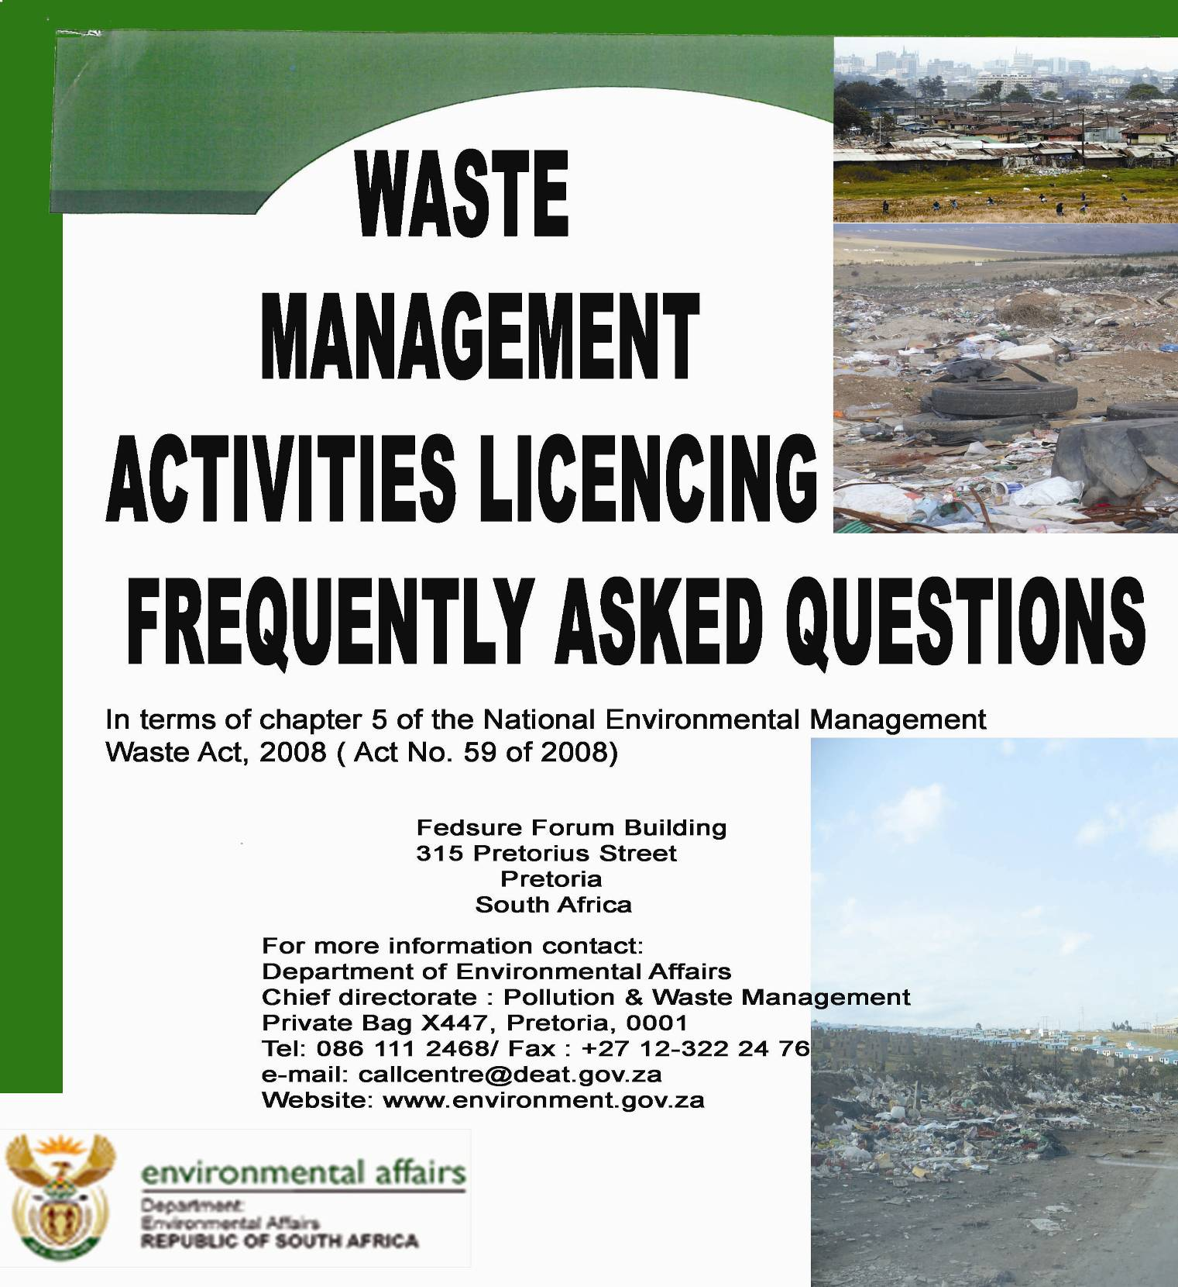

DIRECTORATE: AUTHORISATIONS AND WASTE DISPOSAL MANAGEMENT FREQUENTLY ASKED QUESTIONS

QUESTION |  |  |  |  |  |  | RESPONSE
Q1 Who is the competent authority with regards to waste licensing |  |  | R1 The Minister of Water and Environmental Affairs is the licensing authority in respect of all activities listed in terms of Section 19 of the National Environmental Management waste Act 2008 (no. 59 of 2008) “NEMWA” pertaining to hazardous waste. NB: should a province exercise their right in terms of S 43 (3) (a), the Member of the Executive Council of a province who is responsible for waste management in the province “MEC” following the gazetting of such a decision will be the licensing authority even for hazardous waste.  The “MEC” is the licensing authority in respect of all activities listed in listed in terms of Section 19 of NEMWA pertaining to general waste.
Q1.1 Where can I get the current list of waste activities listed in terms of Section 19 of the National Environmental Management waste Act 2008 (no. 59 of 2008). |  |  |  | R1.1 The list can be obtained from the South African Waste Information Centre web address: www.sawic.org.za under the folder “waste policy and regulation”. (see picture below)  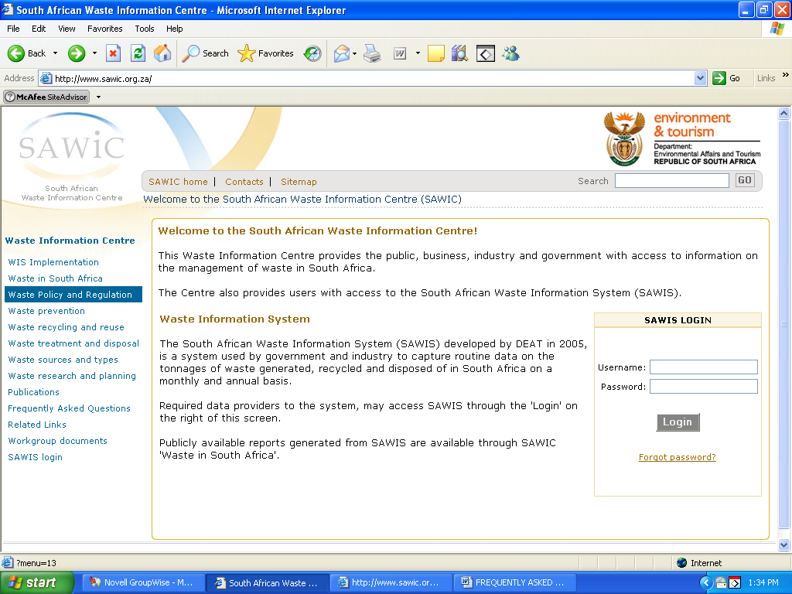
Q1.2 Who is the licensing authority if the activity involves both hazardous and general waste |  |  |  |  |  |  |  |  |  |  |  |  |  |  |  |  |  |  |  |  |  |  | R1.2 The minister is the licensing authority, in terms of S43 (1) (e) of NEMWA.
Q2 Where do I submit an application for a new waste licence/ licence variation? |  |  |  |  |  |  | R2 The application for both must be submitted to the relevant licensing authority (refer to R1 for relevant licensing authority) Each licensing authority has different requirements, please contact them at the following addresses:  The Director: Authorisations and Waste Disposal  Management  Department of Environmental Affairs  Private Bag X447  PRETORIA  0001  Tel: 012 310 3536  Fax: 012 310 3753  Head of the Department  Department of Environmental Affairs and Development  Planning  Private Bag X 9086  CAPE TOWN  8000  Fax: 021 483 4425  Tel: 021 483 5109  Head of Department  Department of Economic Development and Environmental  Affairs  Private Bag X 0054  BHISHO  5605  Fax: 040 609 4700  Tel: 040 609 4702  Head of Department  Department of Economic Development Tourism and  Environment Affairs  Private Bag X 20801  BLOEMFONTEIN  9300  Fax: 051 400 4772  Tel: 051 400 4917  Head of Department  Department of Agriculture and Rural Development  P.O. Box 8769  JOHANNESBURG  2000  Fax: 011 333 0667  Tel: 011 355 1927  Head of Department  Department of Agriculture Environmental Affairs and Rural  Development  Private Bag X 9059  PETERMARITZBURG  3200  Fax: 033 355 9593  Tel: 033 355 9621  Head of Department  Department of Economic Development, Environment and  Tourism  Private Bag X 9484  POLOKWANE  0700  Fax: 015 291 5809  Tel: 015 291 5447  Head of Department  Department of Economic Development Environment and  Tourism  Private Bag X 11215  NELSPRUIT  1200  Fax: 013 766 4613  Tel: 013 766 4179  Head of Department  Department of Agriculture, Conservation and Rural  Development  Private Bag X 2039  MMABATHO  2735  Fax: 018 389 5006  Tel: 018 389 5341  Head of Department  Department of Environmental Affairs and Nature  Conservation  Private Bag X 6102  KIMBERLEY  8300  Fax: (053) 807 7367  Where the Minister is the licensing authority, the applicant must fill in all relevant sections of the application form. Incomplete applications will not be processed. The applicant will be notified of the missing information in the acknowledgement letter that will be sent within 14 days of receipt of the application. Sections in the form that do not apply to the applicant must be marked “not applicable”  It is the responsibility of the Applicant/Environmental Assessment Practitioner “EAP” to download the most current version of the application form from the South African waste information centre website (www.sawic.org.za) .( refer to picture In R1.1)  Four hardcopies of the application form must be submitted to the Directorate: Authorisation and Waste Disposal Management. The applicant must contact the relevant provincial office regarding the number of copies required to process waste licence applications where provincial departments are the licensing authorities. All application forms must be signed and those that are not signed or completed accordingly will not be considered.  Where the application form is submitted with applicable reports, each application form must be accompanied by a copy of reports and other documents required in terms of the EIA Regulations.  The applicant must clearly mark confidential sections of the information submitted in the application form and supporting documents. All other information will become public information on receipt by the licensing authority.
Q2.1 Where can an application form for waste activity authorisation be obtained? |  |  |  |  | R2.1 Where the Minister is the Licensing Authority, an application form for licensing can be downloaded from the South African Waste Information Centre web address: www.sawic.org.za under the folder “Waste Treatment and Disposal”. (Refer to picture in R1.1) For Activities where the MEC is the licensing authority please contact the relevant Province (refer to R2 for relevant contact details).
How does one apply for a licence or a permit amendment & what does the process entail? |  |  |  |  |  |  | In terms of the Waste Act, the amendment is referred to as a variation. For Licence variations please familiarize yourself with the requirements of S54 of NEMWA. Any variation application must be accompanied by a copy of the latest external audit report.
Q3 How many copies of application and supporting documents must be submitted |  |  |  |  |  |  | R3 Where the Minister is the licensing authority, four hard copies & one scanned copy where possible. In cases where the MEC is the licensing authority the relevant province must be contacted (refer to R2 for relevant contact details).
Q4 Is there an application fee |  |  |  |  |  |  |  |  |  |  |  | R4 Currently there is no prescribed fee.
Q5 What is the definition of waste |  | Any substance, whether or not that substance can be reduced, reused, recycled and recovered:  (a)That is surplus, unwanted, rejected, ,discarded, abandoned or disposed of  (b) which the generator has no further use of for the purpose of production  (c) that must be treated or disposed of  (d) that is identified as a waste by the Minister by notice in the Gazette, and includes waste generated by mining, medical or other sector, but :  (i) a by- product is not considered waste  (ii) any portion of waste, once reused, recycled and recovered, ceases to be waste.
Q6 What is a waste management activity |  |  |  |  |  |  |  |  |  |  |  |  |  |  |  |  |  |  | R6 Any activity listed in terms of S19 of NEMWA
Q7 Are by-products that will be used as input material for another process regarded as waste |  |  |  |  |  |  |  |  |  |  |  |  |  |  |  |  |  |  | R7 A by product is not waste provided it fits the definition of by-product as given in the Waste Act.
Q8 Why is it necessary to submit co-ordinates for all corners of the site if the centre coordinates have already been submitted |  |  |  |  |  |  |  |  |  |  |  |  |  |  |  |  |  |  | R8 The Department requires geographical co-ordinates for auditing purposes and for mapping of waste management facilities.
Q9 What is regarded as temporary storage of waste as opposed to continuous storage. |  |  |  |  |  |  |  |  |  |  |  |  |  |  |  | R9 Temporary storage means ongoing storage of waste excluding a once off storage of waste for a period not exceeding 90 days.
Q10 What is the difference between a licence and an environmental authorisation and which department is the competent authority in each case. |  |  |  |  |  |  |  | R10 A waste licence is issued for activities listed in terms of S19 of National Environmental Management waste Act 2008 (no. 59 of 2008). An Environmental Authorisation when used in Chapter 5 of The National Environmental Management Act “NEMA” means the authorisation by a competent authority of a listed activity in terms of that Act.
Q11 How long does the licensing process take? | R11 Procedure and duration for licensing is in accordance with that stipulated R385 made under section 24(5) of the National Environmental Management Act, 1998 ( Act 107 of 1998) Basic Assessment must be applied to an application if the authorisation applied for is in respect of an activity listed in Category A of the Waste Activity List (Government Notice No. 32368).  14 day for acknowledgement of application  30 day to consider basic assessment report  Scoping and EIA must be applied to an application if the authorisation applied for is in respect of an activity listed in Category B of the Waste Activity List (Government Notice No. 32368).  14 days to acknowledge application  - 30 days to consider scoping report  - 60 days to consider Environmental Impact Assessment Report  - 45 days to issue/ refuse authorisation
Q12. Where can a list of authorised waste management facilities in the country be obtained? |  |  |  |  |  |  |  |  |  |  | R12 A list of all authorised sites may be obtained from the South African Waste Information Centre web address: www.sawic.org.za under the folder “Waste Treatment and Disposal”. (refer to picture in R1.1)
Q12.1 How can a copy of a waste licence for a particular site be accessed? |  |  |  |  |  |  |  |  |  |  |  |  |  | R12.1 A waste licence is a public document and can be obtained directly from the licence holder by any interested and affected party.
Q13 Does a holder of an Environmental Authorisation still need to apply for a waste licence? |  |  |  | R13 Where a S20 permit was required prior to July 2009 the proponent must go ahead and apply for a licence. Where it was not (where environmental authorisation was the only requirement) S81 (2) of NEMWA applies “The holder of a permit issued in terms of section 20 of the Environment Conservation Act must apply for a waste management licence in terms of this Act, when required to do so by the licensing authority, in writing, and within the period stipulated by the licensing authority”.
Q14 In terms of the DWAF Second Edition, 1998. Waste Management Series. Minimum Requirements “waste material should always be stored separately from other process chemicals or products”. What does separately mean? |  |  |  |  |  |  |  |  |  |  |  |  |  |  |  |  |  |  |  |  | R14 “Separately” must be used as defined in the dictionary. Once any material is mixed with waste it will be considered as waste and will be subjected to waste licensing requirements where applicable.
Q15 How can the status of a waste licence application be tracked |  |  |  |  |  |  |  |  | R15 For every waste licence application submitted to the national department an acknowledgement letter with a contact person will be sent to the applicant.
Q16 What is the correct way of disposing of tyres |  |  |  |  |  |  |  |  |  |  |  |  |  |  |  |  |  |  | R16 See Waste Tyre Regulations of 2008
Q17 What procedures must be followed in order to set up a landfill site? What legislation must be considered? |  |  |  |  |  |  | R17 For procedures to set up a landfill site please refer to the DWAF 2nd Ed. 1998, Minimum Requirements available from www.sawic.org.za under Treatment and Disposal”. (refer to picture in R1.1). A legal expert must be consulted in terms of what legislation to consider.
Q18 At the end of the Waste Activities List it states that: Persons who lawfully conduct waste management activities listed in this Schedule on the date of the coming into effect of this Notice may continue with those activities until such time that the Minister by notice in the Gazette calls upon those persons to apply for waste management licences. Does this mean that a company in operation that should have had a S20 permit for waste storage can wait until they are requested to apply for a licence? Does lawfully only refer to companies that have a S20 permit already? |  |  |  |  |  |  |  |  |  |  |  |  |  |  |  |  |  |  |  |  |  |  |  |  |  |  | R18 Lawfully means you had a S20 permit or you were no required to have a permit in terms of S20 of ECA.
Q19 What about the days before EIAs, such as big industries that were storing lots of waste before this whole debate / interpretation of ECA S.20 Permits came about? How should one advise them to proceed or should they write for clarification from your Department? |  |  |  |  |  |  |  |  |  |  |  |  |  |  |  |  |  |  |  |  |  |  |  | R19 They were required to have permits in terms of S20 of the Environment Conservation Act.
Q20 What is the status of the current “Minimum Requirements” series developed by the erstwhile Department of Water Affairs and Forestry? |  |  |  |  |  |  |  |  |  |  |  |  |  |  | R20 The Department of Water Affairs and Forestry, Second Edition, 1998, Waste Management Series, Minimum Requirements are still valid and will only fall away when the relevant Norms and Standards required in terms of S.7(1)(c) of NEMWA are in effect.
Q21 Is it possible to delist dry hazardous waste to a GLB⁻ site. The “Minimum Requirements” mentions that waste can only be delisted to GLB⁺ sites within General Landfills. |  |  |  |  |  |  |  |  |  |  |  |  |  |  |  |  |  |  |  |  |  |  | R21 No, hazardous waste can only be delisted to a GMB⁺ or GLB⁺ site due to the fact that they have leachate containment.
Q22 Under Category B of GN 718 Waste Management Activity No. 3 talks about the recovery of waste as an integral part of an internal manufacturing process within the same premises. The clause “within the same premises” does it refer to the premises where the waste is generated or does it refer to the site where waste is recovered? |  |  |  |  |  |  |  |  |  |  |  |  |  |  |  |  |  |  |  |  |  |  |  |  |  |  |  | R22 It refers to Both within the same Premise
Q23 In the case where one is undertaking two activities where one falls under R386 and GN 718, does one need to conduct two separate Scoping & EIA process for the two activities? |  |  |  |  |  |  |  |  |  |  |  |  |  |  |  |  |  | R23 The process is one; the applicant must check which one is the main activity. Where the waste management activity is the main activity an application must be sent to the waste licensing authority (see R1 for licensing authority).
Q24 Does recyclable waste fall under the definition of “General Waste” for the purpose of Schedule 1 of the Waste Act for temporary storage under 30 tonnes? |  |  |  |  |  |  |  |  |  |  |  |  |  |  |  |  |  |  |  |  |  |  |  |  | Q24 No, Hazardous waste can be recycled.
Q25 Does Licences applied for in terms of Schedule 1 Activities require the actual storage capacity of a container/yard or the volume of waste being stored, reused, recycled, recovered, treated and/or disposed? For example, if I have the capacity to store 50 tonnes of general waste but never store more than 1 ton will I require a NEMWA S.20 Licence. |  |  |  |  |  |  |  |  |  |  |  |  |  |  |  |  |  |  |  |  |  |  |  |  |  | R25 Yes a waste licence is required based on the capacity of the facility.
Q26 Can EIAs and waste licences be done under the same application? |  |  |  |  | R26 In terms of NEMWA you are not supposed to do an EIA and a Licence for a Waste Activity separately. The NEMWA S.20 Licence serves as both a Waste Licence and an EIA Authorization That is why the List of Activities requiring a NEMWA S.20 Licence are those of Government Notice No. R 385 (EIA Regulations).
Q27 Are Ash and Pith from a paper manufacturing process considered “waste” or “by- products”? |  |  |  |  |  |  |  |  |  |  |  |  |  |  |  |  |  |  |  |  |  |  |  |  |  |  | R27 Ash is waste
Q28 How can EIA processes that are currently underway be beefed up to meet all the requirements and end in a Waste Licence being issued? |  |  |  |  |  |  |  |  |  |  |  |  | R28 Applicants will have to fill in the Waste Licence Application form available on www.sawic.org.za and supply the Department with all the information stipulated in this Application Form in order to be issued with a NEMWA S.20 Licence.
Q29 What happens to EIA processes currently underway where the “competent authority" in terms of the NEM: Waste Act changes (e.g. Hazardous Waste)? |  |  |  |  |  |  |  |  |  |  |  |  |  |  |  |  |  |  |  | R29 National and Provincial Departments have reached agreement to process applications to finality and then send to the competent authority to issue.
Q30 What happens to waste activities being undertaken as part of a bigger development also subjected to EIA process? |  |  |  |  |  |  |  |  |  |  |  | R30 National and Provincial Departments have reached agreement that the EIA Officials who receive such applications will send copies of the necessary documentation to their relevant Waste Officials for processing the Waste Licence.
Q31 The NEM: Waste Act is very sketchy about the Waste Licence Application process. |  |  |  |  |  | R31 The Waste Licence Application Form serves as a guide regarding what is required and in the latter part of the year this Form will be supplemented with other guiding materials for applicants depending on the lessons learnt from the current Application process.
Q32 What happens with EIA processes underway before 1 July 2009 where Province is the competent authority & remain so? |  |  |  |  |  |  |  |  | R32 General Waste EIA/BA Applications that pertained to waste activities only are to be issued as Waste Licences; however where the application entailed numerous activities in terms of the EIA regs, the province will still have to issue the RoD and a Waste Licence.
Q33 What happens with EIA processes underway before 1 July 2009 where Province is the competent authority for the EIA but National is competent authority for waste licence? |  |  |  |  |  |  |  |  |  |  |  |  |  |  | R33 Hazardous Waste EIA application to be finalized by Province in terms of an RoD and forwarded to DEA to issue the NEMWA S.20 Licence. If the application entailed numerous activities in terms of the EIA regs, the Province Department will still have to issue the RoD and a Waste Licence wil be issued by National.
Q34 What happens with EIA processes underway before 1 July 2009 where National is the competent authority and remain so |  |  |  |  |  |  |  |  |  | R34 Hazardous waste applications that pertained to waste activities only are to be issued as waste licences; however where the application entailed numerous activities in terms of the EIA regs, the DEA will still have to issue the RoD and a Waste Licence.
Q35 Will there be a new system different from NEAS for tracking Waste Licences? |  |  |  |  |  |  |  |  |  |  |  |  |  |  |  |  | R35 NEAS will be used for all applications, including Waste Licence Applications.
Q36 How will Licencing in the NEM: Waste Act be implemented without regulations that outline the application process? |  |  |  |  |  |  |  |  |  | R36 There is no need. It would be duplication as the BA and EIA process are well documented and they are the same process that waste licensing follows. Moreover, contents of a waste management licence are stipulated to give guidance in terms of the kind of information required.
Q37 Section 44 of the NEM: Waste Act requires of the Licencing authority to (as far as is practical in the circumstances) coordinate and consolidate the application and decision making processes as contemplated in the NEMWA with the process for environmental authorisations as contemplated in Chapter 5 of NEMA. |  |  |  |  |  |  |  |  |  |  |  |  |  |  |  |  |  |  |  |  |  | R37 The integration cannot happen for all authorizations all at once. Currently EIA/BA and the former ECA S.20 processes are combined into one process and there are efforts towards full integration with other authorizations but it will be years from now.
Q38 What is the procedure when applying for waste delisting |  |  |  |  |  |  |  |  |  | Q38 The waste delisting procedure may be obtained form the SAWIC website under the folder “Waste Treatment and Disposal”.

