



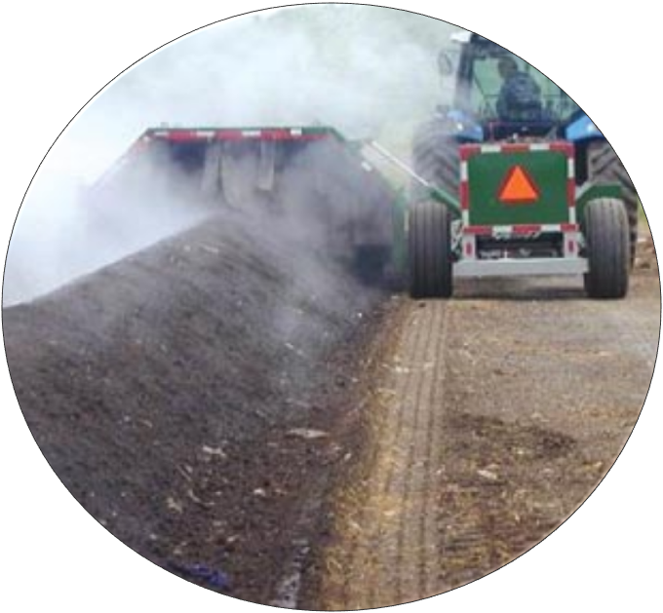
2014
Guide for the effective implementation of Part 8 of the National Environmental Management Waste Act No. 59 of 2008
User Friendly Guide
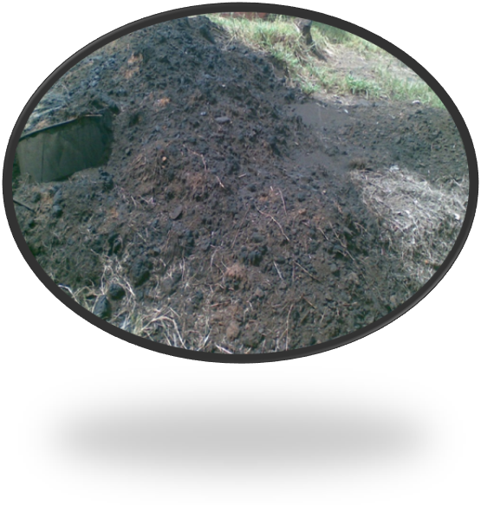

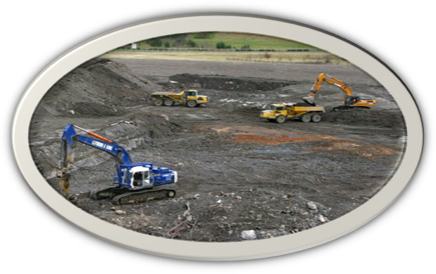

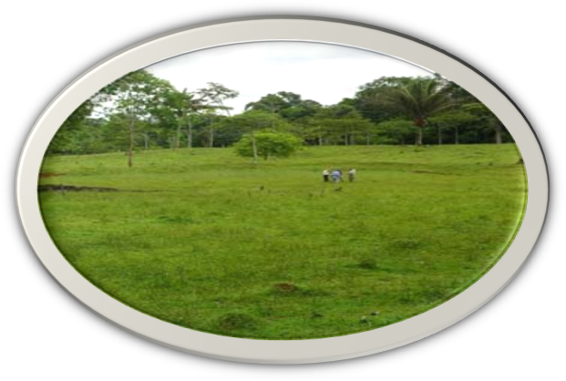

Issued by
Department of Environmental Affairs
Private Bag X 447
Pretoria
0001 South Africa
Disclaimer:
This document is meant for information and clarification purposes only and has no legal authority neither does it take precedence over Part 8 of the National Environmental Management Waste Act No. 59 of 2008. It does not stand in place or substitute meanings of any wording of the Act and should at all times read with the NEM: Waste Act (Act No. 59 of 2008).

Acts of parliament are from time to time amended therefore the reader is advised to consider the latest version of the Act which will be available at the Department of Environmental Affairs.

Acknowledgment:

Branch: Chemicals & Waste Management
Directorate: Law Reform
Working Group IX members

Enquiries and comments

All enquiries and comments should be addressed to:
The Director: Land Remediation
Department of Environmental Affairs
Private Bag X 447
Pretoria
0001 South Africa

Reference: This document should be referenced as: Department of Environmental Affairs (2014). Guide for the effective implementation of Part 8 of the National Environment Management: Waste Act, 2008. South Africa. Pretoria.

ACRONYMS

DEA: Department of Environmental Affairs
DWA: Department of Water Affairs
PDEA: Provincial Department of Environmental Affairs
NCLR: National Contaminated Land Register
NEMA: National Environmental Management Act, 1998 (Act No. 107 of 1998)
NEM: WA: National Environmental Management: Waste Act, 2008 (Act No. 59 of 2008)
SAR: Site Assessment Report

DEFINITIONS

In this document, unless the context indicates otherwise, word or expression that is defined in the National Environmental Management Act, 1998 (Act No. 107 of 1998) (herein referred to as NEMA) and the National Environmental Management: Waste Act, 2008 (Act No 59 of 2008) (NEM: WA) (herein referred to as the Act) has the same meaning-

“Competent Authorities” means any person or organization that has the legally delegated or invested authority, capacity, or power to perform a designated function.
“Independent person” means a person who is not an employee of, and not otherwise related to, the entity, and is not influenced or controlled by the person whom was ordered to conduct a site assessment in matters of opinion, execution and or conduct on such site assessment.
“Regulations” means the regulations in terms of section 69 (1) (v) of the Waste Act;
“Remediation” means the management of a contaminated site to prevent, minimise, or mitigate harm to human health or the environment.
“Site assessment report” means a report compiled in terms of Section 37 of the Act;
“Site” means an area where investigation and/or remediation activities will take place

TABLE OF CONTENTS

ACRONYMS ii
DEFINITIONS iii
TABLE OF CONTENTS iv
1 Introduction 1
2 Purpose of the document 2
3 Limitation of this document 2
4 Competent Authorities 2
5 Content of Part 8 of the Act 2
5.1 Application of Part 8 2
5.2 Identification and notification of investigation areas 2
5.3 Consequences of identification and notification of investigation areas 2
5.4 Consideration of the site assessment reports 3
5.5 Orders to remediate contaminated land 3
5.6 Transfer of remediation sites 3
5.7 Contaminated land register 4
6 Monitoring of the Remediation Site 4

Introduction

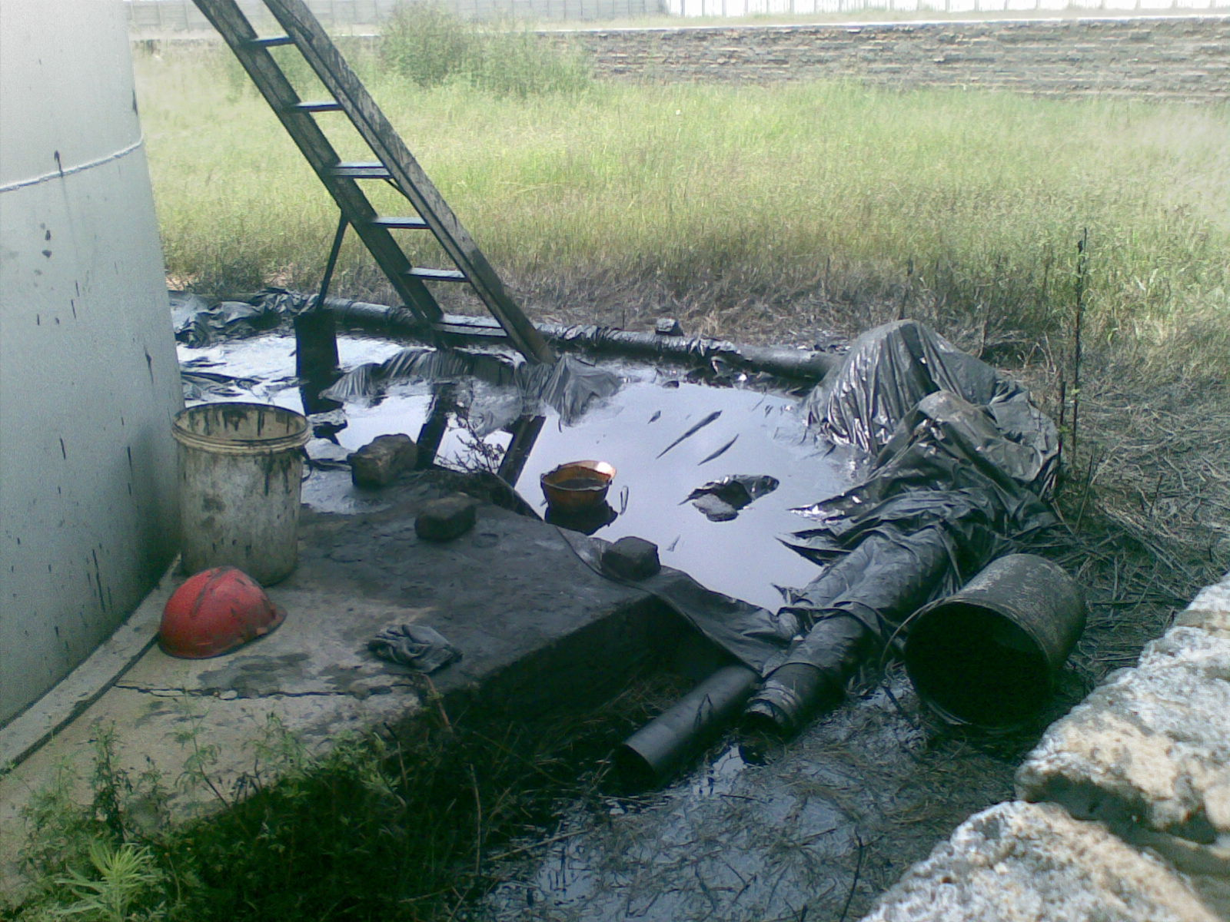
In the past, waste was dumped in rivers or open land and this led to the contamination of the land. Some sources of contaminated sites include abandoned warehouses, manufacturing facilities, processing plants and landfills, mining and agricultural activities etc. The remediation of contaminated land is one of the main elements of sustainable environmental management. It is one of the measures that is implemented to ensure that everyone has the right to the environment that is not harmful to their health and wellbeing. In light of the above, the department promulgated the National Environmental Management: Waste Act, 2008 (Act 59 of 2008) in order to protect human health and the environment by providing measures for the remediation of contaminated land as stipulated in Part 8 of the Act. Part 8 of the Act also applies to land that was contaminated before the promulgation of the Act. Furthermore, it outlines the process that must be applied in implementing Part 8 of the Act. It takes recognition of identification and notification of investigation areas, consequences of identification and notification of investigation areas, consideration of site assessment reports, order to remediate contaminated land, transfer of remediation site as well as Contaminated land register. This document provides for the effective and efficient implementation through a simplified version of Part 8 of the Act. Figure 1 below indicates high risk activity that led to hydrocarbon contamination.

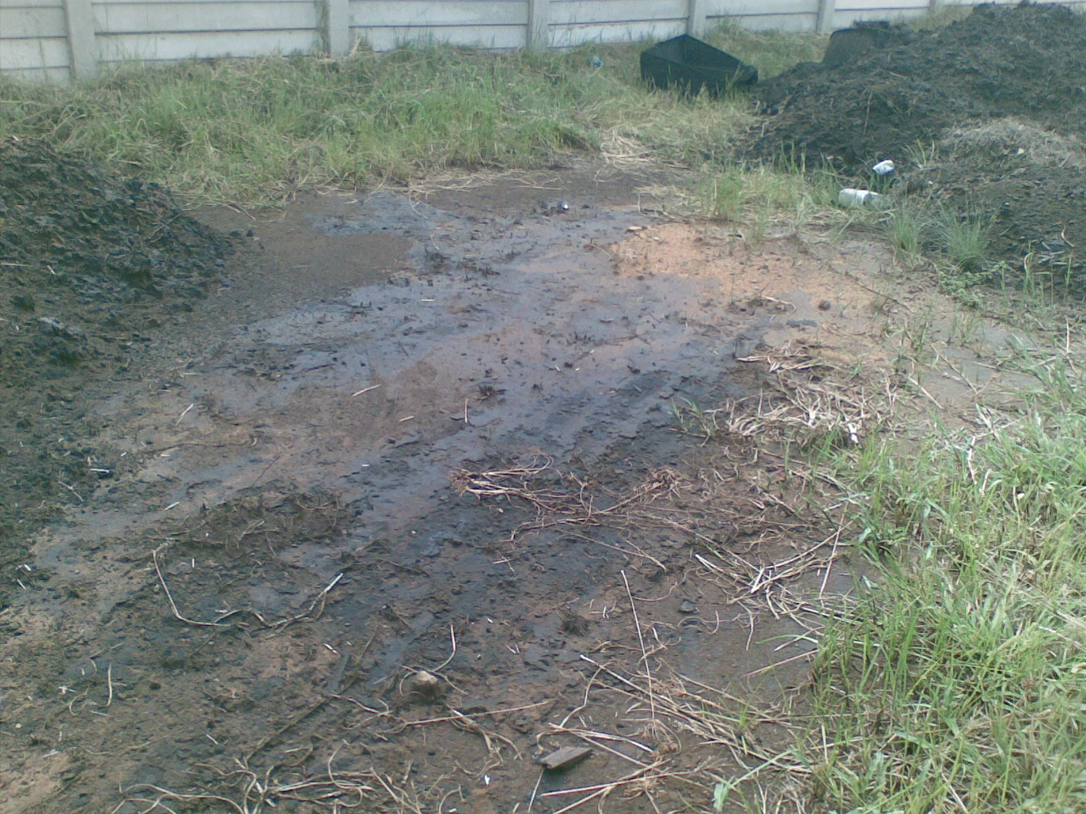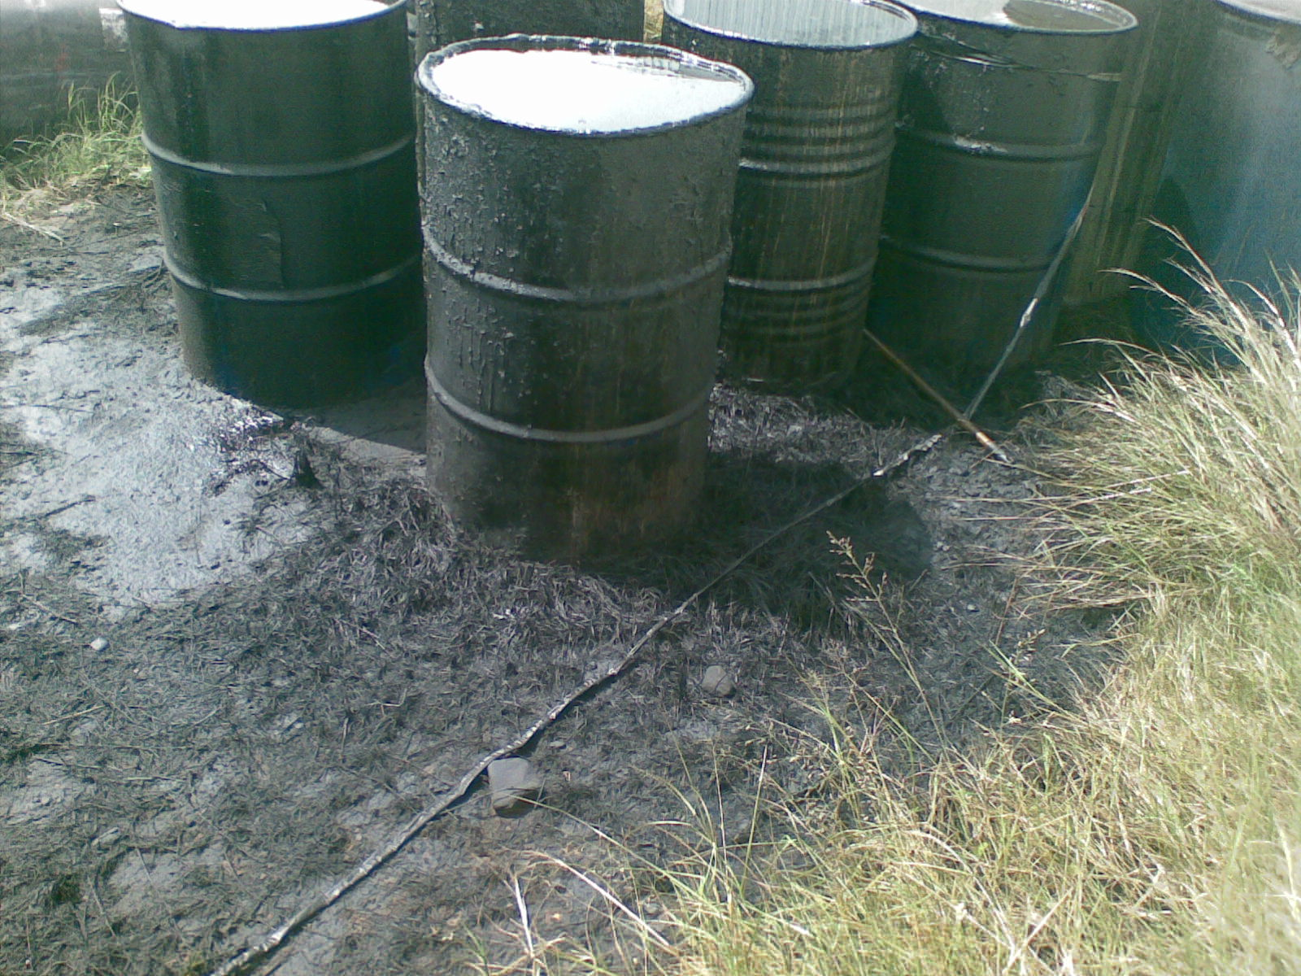

Figure 1: Site contaminated with hydrocarbon contaminant

Purpose of the document

This document aims to simplify Part 8 of the Act such that it is more understandable.

Limitation of this document

This document should be read in conjunction with Part 8 of the Act, its Policies, and Norms and Standards as gazetted.

Competent Authorities

The remediation of contaminated land involves the National Department of Environmental Affairs (DEA), Provincial Department of Environmental Affairs (PDEA), Department of Water Affairs (DWA), and Registrar of Deeds.

Content of Part 8 of the Act

Application of Part 8

This part is applicable to land that has been contaminated even before the promulgation of Act. It further applies to areas were high risk activities were or are taking place that have significant potential to contaminate land such as manufacturing facilities, processing plants and waste disposal facilities, mining and agricultural activities, petroleum refineries, etc.

Identification and notification of investigation areas

The Minister or MEC in consultation with any other organ of state may identify investigation areas were high risk activities have been conducted, or are conducted, or on reasonable ground believe that the area is contaminated. The owner of the land that is contaminated or person who undertakes activity that led to contamination has the responsibility to notify the Minister or MEC as soon as he/she becomes aware of the contamination.

Note:
Information to be submitted to the Minister or MEC as part of the notification of contaminated land can be accessed from www.sawic.environment.gov.za

Consequences of identification and notification of investigation areas

After identification and/or notification of the investigation area, the Minister or MEC may direct land owner or person to appoint an independent person to conduct a site assessment at their own cost and submit the site assessment report to the Minister or MEC. The findings of the site assessment report will determine whether the investigation area is contaminated or not. It is of great importance to note that the investigation area may be regarded as contaminated even if the findings of a site assessment report does not indicate harm to health or the environment at the particular time but has potential detrimental impact.

Note:
Access the copy of Norms & Standards from www.sawic.environment.gov.za

Consideration of the site assessment reports

Upon receipt of a site assessment report, the Minister or MEC in consultation with other organ of state may decide that an investigation area is not contaminated or is contaminated and must be remediated or the risk must be monitored and managed. In cases where the site must be remediated, the land owner or person must appoint an independent person to compile a remediation plan which amongst other things provides remediation objectives and future land use. Furthermore, the Minister or MEC may declare a contaminated area as a remediation site and issue a remediation order or order in which the land owner or person must comply with.

Orders to remediate contaminated land

The remediation order or an order will provide details of the remediation site and conditions that must be complied with during remediation of the site. The Minister or MEC may instruct officials within his or her Department to ensure compliance with the remediation order or an order. Non-compliance with the remediation order or order is an offence.

Note:
Offences and Penalties
Section 67(1) provides for a number of offences in terms of part 8 of NEMWA. A person who contravenes or fails to comply with section 38(2) or (3) and/or 37(1) is liable to a fine not exceeding R10 million or to imprisonment not exceeding ten (10) years, or both such fine and such imprisonment, in addition to any other penalty or award that may be imposed or made in terms of the National Environmental Management Act. And a person who contravenes or fails to comply with section 36(5) or 40(1) is liable to a fine not exceeding R5 million or to imprisonment not exceeding five (5) years, or to both such fine and such imprisonment

Transfer of remediation sites

The land declared contaminated by the Minster or MEC, cannot be transferred to any person without informing the person whom the land is transferred to that it is contaminated. In case of remediation site, the land owner must notify the Minister or MEC of his/her intention to transfer the land for compliance with the remediation order or order. Subsequently, the new land owner must comply with the conditions of the remediation order or order. The MEC must notify the Minister of the contaminated land within their jurisdiction. The Minister must notify the Registrar of Deeds to note a caveat against land declared as contaminated.

It is not the role of the Conveyancer or land Evaluator to determine whether the land is contaminated or not. However, it is important for the land Evaluator to liaise with the Minister to determine if the land to be transferred or sold is not in the NCLR. The purpose of consultation is to ensure that the new owner is aware of the possible environmental liability he/she may incur if the land is contaminated. In determining the liability cost, the land Evaluator is advised to consult the owner of contaminated land.

Contaminated land register

Part 8 of the Act makes provision for the Minister to maintain a National Contaminated Land Register (NCLR). The register must include details of the land owner or person, site location, types of contaminants, and status of contamination. Once the contaminated land has been remediated and the findings demonstrate that the order or remediation order has been complied with, in case where the MEC is the competent authority he/she must inform the Minister. The Minister must change the status of the remediation site and notify the Registrar of Deeds to remove a caveat.

Monitoring of the Remediation Site

The land owner or person responsible for contamination must ensure an ongoing management and monitoring of the remediation site is carried out until the site is fully remediated to the satisfactory of the authorities. The Minister or the MEC must issue a consent letter to the land owner to declare that the remediation objectives has been achieved and the site may be used for intended purpose as indicated in the remediation plan. Figure 2, below present a process flow diagram of Part 8 of the Act.

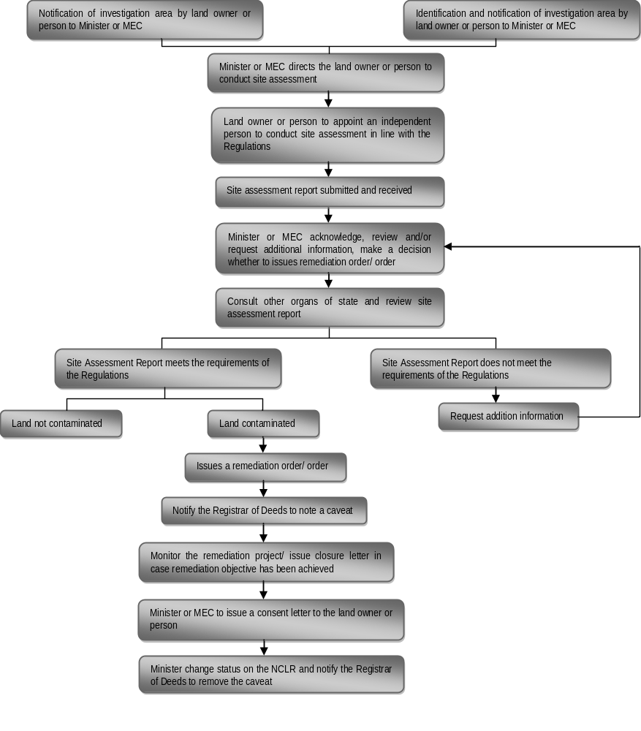

Figure 2: Process flow diagram of Part 8 of the Act

